Dan Coleman R00151926 Embedded Software Security – Assignment 1

Question 1

Locate the private cryptography key stored as plaintext in 2 of the firmware binaries.
Firstly, we run binwalk on Firmware1.bin, this searches for the file signatures of the bin file which tells us the starting point of different file types. As we can see below the filesystem, which is where we will find the private key. In this case we see the starting point for the filesystem is 0x150000. Next, we use the “dd” command to prune off the blocks before the starting address of the firmware up until the filesystem. We also include bs=1 to show that we want to read and write 1 byte. We save the output of the dd command as Firmware1output.bin. We use ls to see the file has been created.
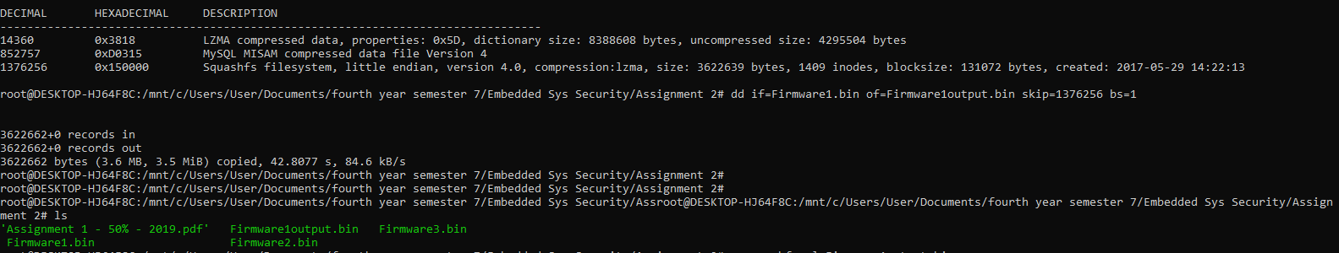
We use unsquashfs to uncompress the file system. Squashfs is a compressed read-only filesystem for Linux. By unsquashing it we can look through the files, in my command I pipelined it and used grep to only view the results that mentioned key. This was not the most optimal method, but with a little trial and error we can find the Private Key by searching each of the files that ends in .key.
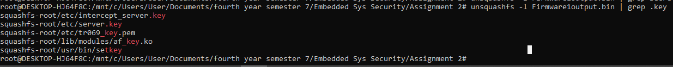
We cd into the correct folder to display the contents of server.key
